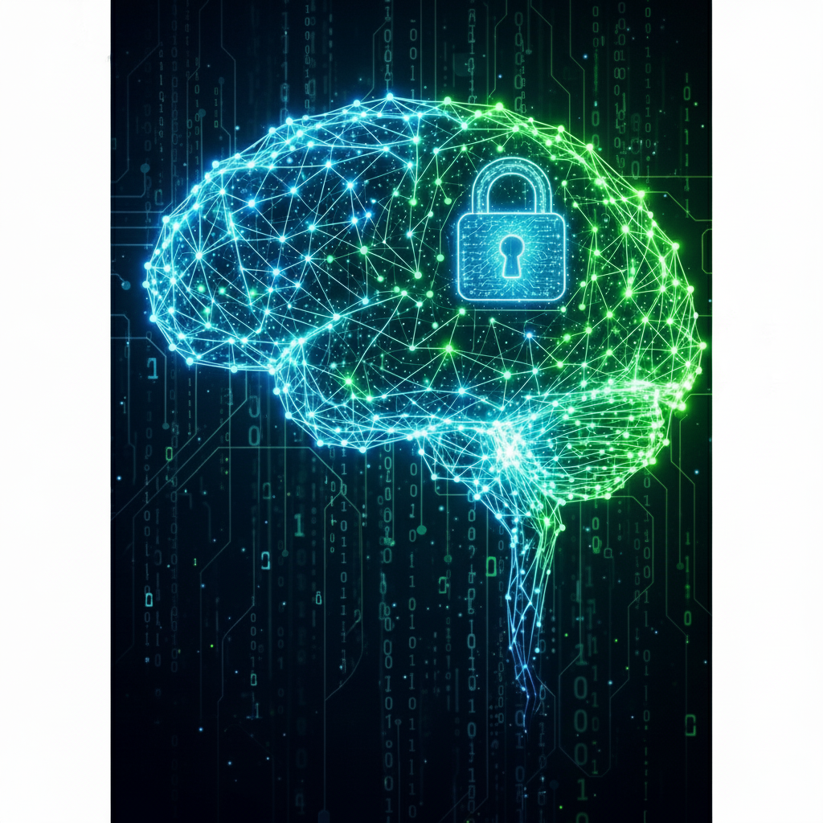

Contents

Future of Cybersecurity from 2025: 1

Introduction: 1

1. The rise of AI/ML: 1

1. Zero Trust Becomes Widespread: 1

2. Quantum Computing 2

3. The advancement in cloud computing 2

4. Biometrics and Multi-Factor Authentication (MFA) 2

5. The Expanding Landscape of Cybersecurity Compliance 3

6. Internet of Things (IOT) Security: 3

Cyber Security domains which will grow in future: 4

Cyber Intelligence: 4

AI in Cyber Security: 4

Passwordless Technology: 5

Digital Forensics: 5

Future Key Trends of Digital Forensics: 6

Am I suitable for cybersecurity and ready to take on the responsibility? 6

Which domain will I choose? 6

Final Thoughts: 7

References: 7

# Future of Cybersecurity from 2025:

## Introduction:

The future's playground and battlefield are both found in cyberspace. As we dive deeper into the digital age, the question of “What is the future of cyber security become increasingly vital? Every year around this time, industry experts and analysts look at the top cybersecurity trends, predictions and challenges for the next year. Over the next decade, the cybersecurity landscape will evolve significantly as new technologies emerge and threats become more sophisticated. Here’s a glimpse into the future of cybersecurity and the trends we can expect.

## The rise of AI/ML:

AI and machine learning will develop from threat detection tools to fully integrated systems that can defend themselves. Artificial intelligence (AI) will play a key role in real-time data analysis to predict, identify, and respond to cyberattacks more quickly and accurately than human teams alone. This is because threats such as polymorphic malware and advanced persistent threats are becoming more prevalent.

Interestingly, AI was quite popular in 2024, security teams are unlikely to utilize it as widely in 2025. According to Forrester Research, there will be a 10% decrease in the use of GenAI for security use cases in the incoming year. AI is powering both offense and defense: attackers are using AI/ML for phishing, deepfakes, adaptive malware, zero-day discovery, etc.

On the defensive side, AI will increasingly be used for predictions, anomaly detection, automated response, real-time correlation across many data sources.

## Zero Trust Becomes Widespread:

The traditional **“castle-and-moat”** approach to security, where everything inside the network is trusted, is no longer effective. The outdated perimeter-based strategy is becoming less and less effective. We'll see Zero Trust models (never trust; always verify) becoming commonplace in large enterprises due to factors like work from home, hybrid cloud, remote devices, internal threats, etc.

To safeguard their networks, businesses will implement Zero Trust principles such as continuous authentication. This strategy will lessen the harm that hacked accounts and insider threats can do.

## Quantum Computing

One new technology that has the potential to significantly improve cybersecurity is quantum computing. Compared to traditional computers, quantum computers may do calculations far more quickly and effectively by utilizing the special properties of quantum physics.

Quantum computing holds immense promise, but it also poses a serious risk to cybersecurity. The advent of quantum computing presents two difficulties. Although it has the ability to crack current encryption, it also presents a chance to develop quantum-resistant cryptographic techniques.

**Cracking encryption:** Current encryption techniques that safeguard private information, such financial transactions and medical records, will be vulnerable to cracking by quantum computers.

**The competition for quantum-safe encryption:** Organizations will increasingly need to plan for “crypto agility” — the ability to swap or upgrade cryptographic algorithms as better ones (resistant to quantum attacks) become standard.

## The advancement in cloud computing

Cloud Computing, a new method of processing and storing data that depends on distant computers is called cloud computing. This gives end users access to a dependable, secure platform to hold their data while enabling organizations to offload some of their IT infrastructures.

As the cyber threat landscape evolves, security measures will surely adopt by organizations. Currently, cloud computing is one of the most effective ways to reduce cyber risk.

Securing cloud environments and guaranteeing the confidentiality, availability, and integrity of data stored in the cloud will be the main goals of future cybersecurity initiatives.

## Biometrics and Multi-Factor Authentication (MFA)

Passwords alone are one of the vulnerable points in cybersecurity and are becoming less and less sufficient for strong authentication. Traditional passwords are about to be replaced by biometric techniques like fingerprints, facial recognition, and even newer choices like pulse patterns to increase security.

These technologies offer a more secure and convenient method of identity verification when used in conjunction with Multi-Factor Authentication (MFA). In the future, behavioral analytics will provide an additional degree of security by observing how users interact with their devices, including typing speed and mouse movement habits, in order to promptly identify anomalous or potentially harmful conduct.

## The Expanding Landscape of Cybersecurity Compliance

As data breaches and the misuse of personal information increase, governments and regulatory agencies worldwide are strengthening cybersecurity and privacy regulations. To satisfy these changing regulatory requirements and protect sensitive data, organizations need to make investments in compliance and strong data-protection procedures.

Historic frameworks like California's CCPA and Europe's GDPR are just the start; many more nations are anticipated to enact laws that force businesses to prioritize user privacy and improve their security procedures.

## Internet of Things (IOT) Security:

The digital attack surface is significantly increased by the Internet of Things (IoT), which links billions of devices, ranging from industrial sensors to wearables and smart household appliances. Cybercriminals can take advantage of the new vulnerabilities brought about by this proliferation, which range from focused assaults on a single smart device to extensive compromises of vital infrastructure transportation networks, and healthcare systems.

In order to ensure the integrity and safety of the enormous amounts of data that these interconnected devices gather, mandated IoT security standards with built-in protections rather than optional add-ons have been adopted.

# Cyber Security domains which will grow in future:

## Cyber Intelligence:

One of the areas of cybersecurity that is expanding the fastest is cyber intelligence, also known as cyber threat intelligence (CTI), which is becoming crucial for businesses of all sizes. Cyber intelligence gathers and analyzes information about adversaries, their strategies, and new threats in order to predict assaults rather than merely responding to them.

|  |  |  |
| --- | --- | --- |
| **Area** | **What It Involves** | **Growth Drivers** |
| **Threat Hunting & Analysis** | Identifying the malware families, infrastructure, and TTPs (tactics, methods, procedures) of attackers. | Demand for the early identification of ransomware and nation-state campaigns. |
| **Dark-Web & OSINT Intelligence** | Monitoring underground forums, marketplaces, and public data sources for stolen credentials or chatter. | Growth of cybercrime markets and need for brand protection. |
| **Malware Reverse Engineering** | Analyzing harmful code to determine its attribution and capabilities. | Continuous evolving of zero-day exploits and malware. |
| **Geo-Political & Strategic Intelligence** | Linking cyber operations to political conflicts. | Critical for defense, finance, and energy sectors. |

## AI in Cyber Security:

Because AI and machine learning improve threat detection and response in real-time, they are revolutionizing cyber security. By enabling automated threat analysis, these technologies help security experts remain ahead of the curve.

Industries have been also transformed by artificial intelligence (AI), but regrettably, cybercriminals are also taking advantage of this technology. In the upcoming years:   
  
Phishing and malware tactics powered by AI will grow more realistic. Based on information about a victim, attackers will employ AI to craft highly customized assaults.  
Hackers will be able to find and take advantage of vulnerabilities at a never-before-seen pace thanks to automated vulnerability discovery.

Although AI was quite popular in 2024, security teams are unlikely to utilize it as widely in 2025. Indeed, according to Forrester Research, there will be a 10% decrease in the use of GenAI for security use cases over the next 12 months.

Scott stated that while GenAI and AI models are praised for their capacity to automate repetitive security productivity activities like reporting and analysis, they are still lacking in incident response capabilities.

## Passwordless Technology:

As businesses and consumers look for increased security and a more seamless login process, the passwordless authentication market is expected to expand quickly in the upcoming years. Eliminating traditional passwords is a logical next step because they continue to be a major source of breaches due to phishing, credential stuffing, and insecure password practices.

Switching to passwordless authentication has several benefits for customers, such as fewer false declines and more seamless customer support interactions. False declines, which occur when valid transactions are inadvertently denied, annoy customers and reduce bank profits.   
  
**According to Lowe**, "a fast card tap can verify identity and reduce the possibility of a false decline." "Customers can authenticate before speaking with an agent, which expedites call center experiences."  
  
High-value operations, such moving retirement assets, are also made safer and easier with passwordless techniques. Passwordless authentication is now a must for banks and big businesses, not an option. Financial institutions need to update in order to be safe and competitive, as big tech companies like Apple and Google are setting the norm and digital identities are becoming more and more linked to digital transactions.

## Digital Forensics:

Digital Forensics is scientific process of locating, saving, evaluating, and presenting digital evidence for use in internal security audits, court cases, or investigations. In order to determine what occurred on digital systems, who was involved, and how to stop similar accidents in the future, it integrates computer science, cybersecurity, and law.

There are **two main purposes** of digital forensics:   
  
**Investigating Crimes and Incidents:** It finds proof of cybercrimes such insider threats, fraud, hacking, harassment, and theft of intellectual property.  
  
**Incident response and recovery:** assist companies in identifying the attack vector, determining the extent of damage, and fortifying defenses following a breach or system failure.   
  
Forensic techniques must adhere to a stringent chain of custody since digital data is susceptible to alteration or destruction. This ensures that data is gathered and recorded in a way that will support it in court or when the government looks into it.

## Future Key Trends of Digital Forensics:

**AI-Powered Digital Forensics:** The use of AI and machine learning (ML) algorithms in digital forensic tools is revolutionizing the field. With AI-powered digital forensics, investigators can analyze massive amounts of data in a fraction of the time, identifying patterns and connections that humans would not be able to perceive.   
  
**Cloud Forensics:** Digital forensic investigators encounter a new challenge as cloud computing grows in popularity. Cloud forensics requires a specific combination of skills and resources to collect, analyze, and store evidence from cloud-based systems.

## Am I suitable for cybersecurity and ready to take on the responsibility?

Yes, I am suitable for this field as I found my keen interest in cyber security. In this digital world where we all are surrounded by technologies, our personal identities, digital data, are all at stake.

I am eager to learn how I can protect not just myself from cyber threats but also that of others. For me cyber security is far more than just a profession. It is a huge responsibility and a long-term commitment.

My goal is to become a skilled cybersecurity professional who not only understands the technical aspects of security but also the strategic importance of protecting organizations from online threats.

## Which domain will I choose?

I am currently building my foundation in this field and have not decided any domain yet but somehow I am attracting towards digital forensics and cyber intelligence as I love to learn about cyber-crimes and analyzing digital evidence.

I'm excited in the investigative aspect of digital forensics and the proactive threat analysis of cyber intelligence because they mix technical expertise with analytical thinking and problem-solving abilities.

I am eager to deepen my understanding in these areas and develop the expertise needed to investigate incidents, attribute attacks, and help organizations stay ahead of emerging threats.

## Final Thoughts:

The future of cyber security is fascinating frontier with both its pros and cons. We’re doing a good job of running our pant legs, however cybersecurity will continue to become more challenging the further we plunge into our technology future, but with plans in place such as AI-enabled defenses, quantum-resistant encryption and by embracing zero-trust tactics that together, we can make informed decisions going forward.

New problems will come over the next ten years, but with right technology and teamwork we can anticipate every possibility. Because the secret is not a reactive policy, but rather one of proactively adapting—keeping informed, updating systems and developing a security-mindset. Governments, companies and individuals can build a safer digital world for everyone by embracing these reforms.

Since cybersecurity is a shared responsibility and being alert is our best defense against the unknown, cooperation, awareness, and resilience will be more crucial in this future than technology alone.

## References:

<https://www.forbes.com/sites/bernardmarr/2023/10/11/the-10-biggest-cyber-security-trends-in-2024-everyone-must-be-ready-for-now/>

<https://medium.com/@Bytecodesec/what-is-the-future-of-cyber-security-5d528cf4b39c>

<https://osintteam.blog/the-future-of-digital-forensics-navigating-the-convergence-of-technology-and-crime-5cac4bd00cff>

<https://medium.com/@okanyildiz1994/mastering-passwordless-technologies-an-in-depth-guide-to-modern-authentication-04f735980696>